Exercise 5 – Attendance Report
Workflow
create_attendance
↓
count_present
↓
count_absent
↓
generate_summary

Input
Rahul,Present
Priya,Present
Amit,Absent
Sneha,Present
Kiran,Absent

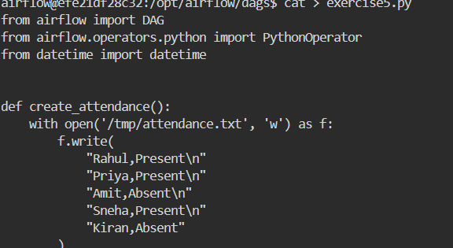

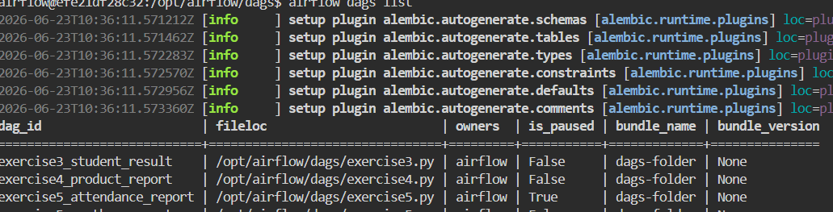

Python Code:
from airflow import DAG
from airflow.operators.python import PythonOperator
from datetime import datetime

def create_attendance():
with open('/tmp/attendance.txt', 'w') as f:
f.write(
"Rahul,Present\n"
"Priya,Present\n"
"Amit,Absent\n"
"Sneha,Present\n"
"Kiran,Absent"
)

def count_present():
present_count = 0

with open('/tmp/attendance.txt', 'r') as f:
for line in f:
name, status = line.strip().split(',')
if status == "Present":
present_count += 1

with open('/tmp/present_count.txt', 'w') as f:
f.write(str(present_count))

def count_absent():
absent_count = 0

with open('/tmp/attendance.txt', 'r') as f:
for line in f:
name, status = line.strip().split(',')
if status == "Absent":
absent_count += 1

with open('/tmp/absent_count.txt', 'w') as f:
f.write(str(absent_count))

def generate_summary():
with open('/tmp/present_count.txt', 'r') as f:
present = f.read()

with open('/tmp/absent_count.txt', 'r') as f:
absent = f.read()

with open('/tmp/attendance_report.txt', 'w') as f:
f.write(
"Total Students = 5\n"
f"Present = {present}\n"
f"Absent = {absent}"
)

with DAG(
dag_id='exercise5_attendance_report',
start_date=datetime(2025, 1, 1),
schedule=None,
catchup=False
) as dag:

task1 = PythonOperator(
task_id='create_attendance',
python_callable=create_attendance
)

task2 = PythonOperator(
task_id='count_present',
python_callable=count_present
)

task3 = PythonOperator(
task_id='count_absent',
python_callable=count_absent
)

task4 = PythonOperator(
task_id='generate_summary',
python_callable=generate_summary
)

task1 >> task2 >> task3 >> task4
Output:

